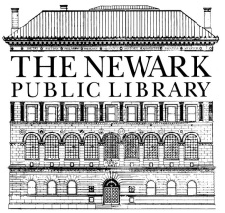
THE NEWARK PUBLIC LIBRARY
5 WASHINGTON STREET
NEWARK, NEW JERSEY 07102

NEWS RELEASE

July 9, 2018
FOR IMMEDIATE RELEASE
Media Contact: Magaly Santiago (973) 733-7731 msantiago@npl.org

NEWARK PUBLIC LIBRARY APPOINTS
SPENCER SCOTT ASSISTANT DIRECTOR OF DEVELOPMENT
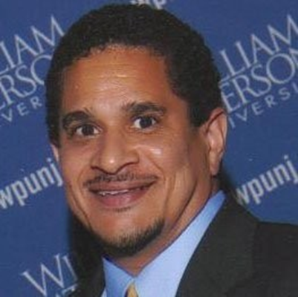
Successful fundraiser with 26 years of experience joins the Newark Public Library
Spencer Scott arrives at The Newark Public Library after 26 years in public relations and fundraising. He began his career as the Director of Public Relations with The Salvation Army State Headquarters when it was located in Newark. After The Salvation Army’s headquarters moved to Union, he assumed the role of Assistant Director of Development where he helped lead the fundraising team that raised $7M annually. He then took a position with New Jersey Institute of Technology, in Newark, where he was responsible for major gifts and planned giving raising money for scholarships and educational programs.
His next position brought him to St. Joseph’s Regional Medical Center in Paterson as the Director of Development where he raised money to support various hospital initiatives and organized the hospital’s annual gala which was held at the Waldorf Astoria in New York City. The event raised $1,000,000. In 2002, Spencer joined the staff of The First Occupational Center of New Jersey in Orange as the Director of Development where he raised money to support programs associated with moving developmentally disabled people for dependence to independence. A move back to healthcare brought him to East Orange General Hospital as the Executive Director of Development where he was instrumental in revitalizing a non-existent fundraising program that included securing gifts and pledges for a $1,000,000 campaign for emergency room renovations and organizing the first “Ball of the Oranges” after a 20 year absence which raised $145,000.
Another move back to higher education brought him to William Paterson University in Wayne as -the Director of Major and Planned Gifts where he has been responsible for raising over $10.2M from 2007 to 2018. Under his direction the planned giving program has grown to include 54 charitable gift annuities for a total of $720,000, secured a $1,000,000 bequest and he cultivated the largest bequest to date at the University in the amount of $5,000,000.
About the Newark Public Library
Since 1888, the Newark Public Library has been an anchor institution in Newark. It is New
Jersey’s most comprehensive public library, serving some 10,000 patrons per week and providing equal access for all to vast educational, cultural, literary, historical and digital resources. Through its Main Library and seven branches, the Newark Public Library provides residents of Newark with reference help for job searches and accessing social services, ESL and computer classes, and family literacy programs. It also contains the Hispanic Research Information Center, James Brown African American Room and the Charles F. Cummings New Jersey Information Center. For more information visit us at www.npl.org.

