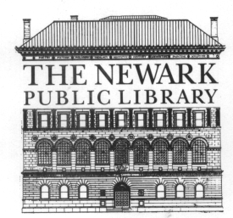

THE NEWARK PUBLIC LIBRARY
5 WASHINGTON STREET, NEWARK, NEW JERSEY 07102

PRESS RELEASE

July 30, 2018
FOR IMMEDIATE RELEASE
Please Contact: Maisy Card Phone: 973-733-7822 E-mail: mcard@npl.org

Newark Public Library Awarded $18,000 Action Grant from

The New Jersey Council for the Humanities

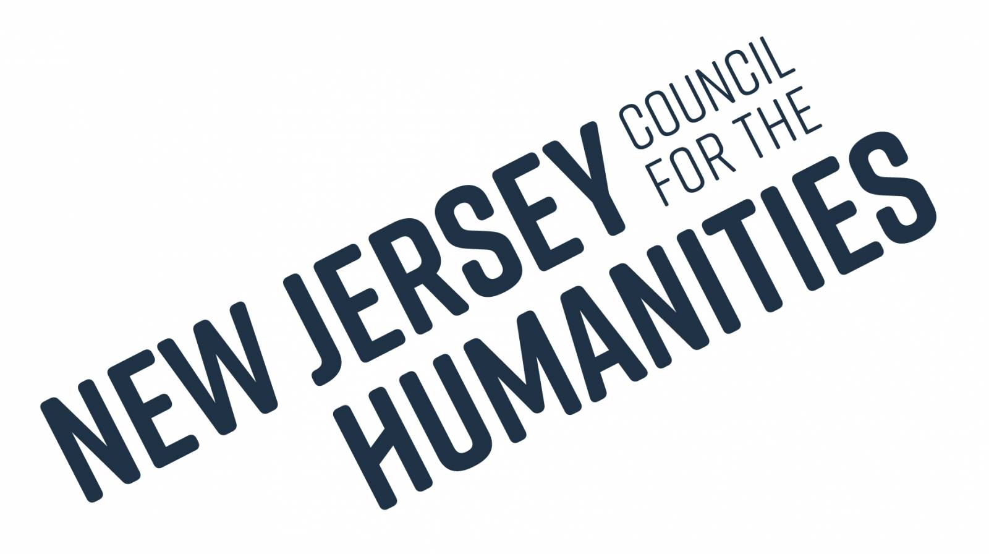
The Newark Public Library has been awarded an $18,000 action grant from the New Jersey Council for the Humanities (NJCH) to provide Poetry/Spoken Word Workshops for underrepresented teens and emerging adults in Newark. The workshops will be led by Newark ­based poet Jasmine Mans, a prominent figure in the local poetry and spoken word community.

Jasmine Mans is an author, performer, poet, teacher, and artist. She is a graduate of Newark's own Arts High School. She received her BA in African-American Studies (Black Theory & Literature) from the University of Wisconsin, and is the recipient of the Star Ledger – NJPAC, Arts Millennia, and (New York) Knicks Poetry Slam Scholarships and awards. Mans released her first book, Chalk Outlines of Snow Angels in May 2012. That same year, she was chosen by Glamour Magazine as one of their Top 10 Most Influential Women in College. Jasmine began mentoring younger poets and teaching creative writing as an undergraduate in the University of Wisconsin’s First Wave program. She recently coached the Newark Slam Team in the Brave New Voices 2018 Youth Poetry Festival in Houston, TX.

She previously led successful teen poetry workshops at the Newark Public Library from October through November 2017, as well as February through May 2018. Her curriculum includes the Harlem Renaissance, the Black Arts Movement, and hip hop.
The grant will fund a series of workshops for teens during summer and fall 2018. Mans will also lead workshops for emerging adults, ages 18 to 24. The workshops will conclude with two open mic showcases. Ms. Mans will also compile and edit an anthology of the participants’ work by spring 2019.

NPL’s mission is to transform lives and strengthen communities through innovative services, stimulating programs, and inspiring collections. By empowering Newark’s youth to tell their stories, equipping them with literacy and public speaking tools they will be able to apply in both academic and professional spheres in the future, and establishing their confidence as artists, the poetry/spoken word workshops will advance our mission to transform and strengthen the community.

Summer workshops will begin at Main Library, the week of July 30th and conclude on August 9th. For more information or to register a teen, please email Maisy Card, Teen Services Librarian, at mcard@npl.org.

.

